Skyline Small Molecule Multidimensional Spectral Libraries (DRAFT)

In this tutorial, you will learn how to utilize spectral libraries and drift time filtering for analysis of complex ion mobility spectrometry-mass spectrometry (IMS-MS) small molecule data. Skyline’s IMS-MS capabilities are compatible for platforms where collision cross section (CCS) values are calculated such as DTIMS, TIMS, and TWIMS instruments. (Skyline also supports FAIMS ion mobility filtering, though that is not covered here.) A spectral library containing *m/z*, retention time, fragmentation, and ion mobility information for a set of lipids in fruit fly samples will be explored and added to the Skyline document. The CCS values for each molecule can then be used to increase the selectivity of precursor and fragment extracted ion chromatograms above what can be realized by high mass resolution alone, thereby reducing interference from other ions.

In this more advanced tutorial, some familiarity with Skyline is assumed. If you are not familiar with Skyline, you should first work through some of the introductory tutorials at

<http://skyline.ms/tutorials.url>

# Getting Started

To start this tutorial, download the following ZIP file:

<https://skyline.ms/tutorials/SmallMoleculeLibraries.zip>

There is a total of over 2 GB of data, so downloading may take a while.

Extract the files in it to a folder on your computer, like:

C:\Users\bspratt\Documents

This will create a new folder:

C:\Users\bspratt\Documents\SmallMoleculeLibraries

It will contain the Skyline files necessary for this tutorial.

The .d files contain data from a male (M) and female (F) fruit fly (*Drosophila melanogaster*) lipid extract.

If you have been using Skyline prior to starting this tutorial, it is a good idea to revert Skyline to its default settings. To do so:

* Start Skyline.
* On the **Start Page,** click **Blank Document** which looks like this:

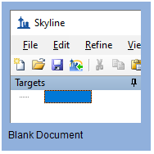

* On the **Settings** menu, click **Default.**
* Click **No** on the form asking to save the current settings.

The settings in your current instance of Skyline have now been reset to the default.

Since this tutorial covers a small molecule topic, you can choose the molecule interface by doing the following:

* Click the user interface control in the upper right-hand corner of the Skyline window, and click **Molecule interface** which looks like this:

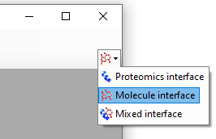

Skyline is operating in molecule mode, as indicated by the molecule icon  in the upper right-hand corner of the Skyline window. Skyline’s proteomics-specific menus and controls are now hidden, allowing you to focus on small molecule analysis.

# Transition Settings

You will need to review the transition settings before adding the spectral library and results data.

To do this, perform the following steps:

* On the **Settings** menu, click **Transition Settings**.
* Click the **Filter** tab.

The transition filter settings are used to decide which library entries are suitable for inclusion in the Skyline document. Only entries with adducts that match the filters will be selected for use.

* In the **Precursor Adducts** field, enter “[M-H], [M+HCOO], [M+CH3COO]”.
* In the **Fragment Adducts** field, enter “[M-]”.
* This data was collected in negative ionization mode so [M+H] and [M+] can be removed from the **Precursor Adducts** and **Fragment Adducts** fields if you see them there. However, they are harmless if left as is since the library that will be used has only negative ion mode entries.

These adducts can also be added using the drop-down menus accessed by the arrow buttons. Navigate to the Adducts- menu, and select the appropriate adducts.

* In the **Ion Types** field, enter “f,p” to include both fragments and precursors in the filter.
* The **Transition Settings** form should now look like this:

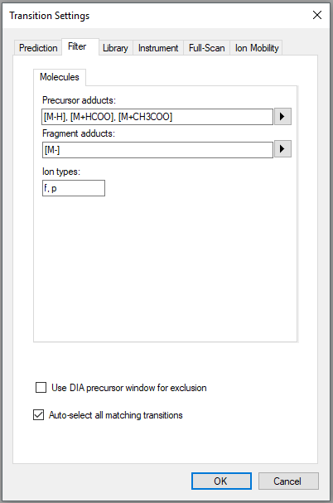

* Click the **Full-Scan** tab in the **Transition Settings** form.
* In the **MS1 filtering** section, set the **Isotope peaks** included field to **Count**.
* Set the **Precursor mass analyzer** field to **TOF**.
* Enter “20,000” in the **Resolving power** field.
* In the **MS/MS filtering** section, set the **Acquisition method** field to **DIA**.
* Set the **Isolation scheme** field to **All Ions**.
* Enter “20,000” in the **Resolving power** field.
* Check **Use high-selectivity extraction**.

The **Transition Settings** form should look like this:

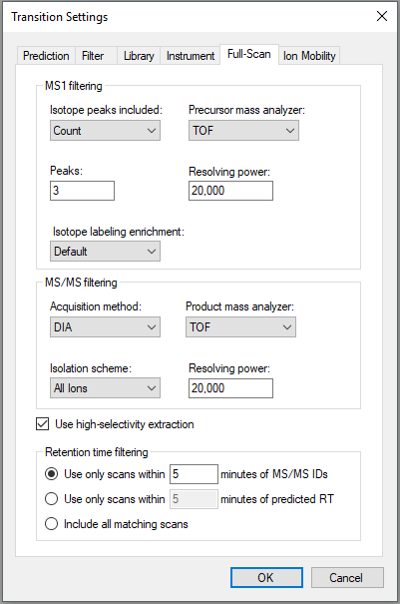

The **Transition Settings** form instructs Skyline to extract 3 precursor isotope peaks from MS1 (low-energy) spectra and fragment ions from MS/MS (high-energy) spectra acquired at ~28,000 resolving power on a TOF instrument. Utilizing lower 20,000 resolving power accounts for the difference in resolving power between ions of different concentrations. The acquisition method “DIA” and isolation scheme “All Ions” indicate to Skyline that the spectra are alternating low- and high-energy without precursor isolation. When **Use high-selectivity extraction** is checked, Skyline extracts a single resolution width around the target *m/z*, and when it is unchecked Skyline extracts 2x the resolution width, which should increase the total number of ions included in the extraction but at the risk of increasing interference.

The **Prediction** tab does not apply to this tutorial and the **Library** and **Instrument** tabs have acceptable defaults. The **Ion Mobility** tab will be revisited later in the tutorial.

* Click the **OK** button.

# Adding and Exploring a Spectral Library

Before you can explore the library, Skyline must be directed to its location by adding your library of interest to the global list of libraries for document editing. The library used in this tutorial was created in Skyline from experimental data and a transition list generated by [LipidCreator](https://skyline.ms/skyts/home/software/Skyline/tools/details.view?name=LipidCreator).

To get started with the small molecule library containing *Drosophila* lipids perform the following steps:

* From the **Settings** menu, click **Molecule Settings**.
* Click the **Library** tab.
* Click the **Edit List** button.
* Click the **Add** button in the **Edit Libraries** form.
* Enter “Drosophila Lipids” in the **Name** field of the **Edit Library** form.
* Click the **Browse** button.
* Navigate to the SmallMoleculeLibraries folder created earlier.
* Select the “Drosophila_Lipids_Neg.blib” file.
* Click the **Open** button.
* Click the **OK** button in the **Edit Library** form.
* Click the **OK** button in the **Edit Libraries** form.

The **Libraries** list in the **Molecule Settings** form should now contain the Drosophila Lipids library you just created.

* Check the Drosophila Lipids checkbox to tell Skyline to use this library in the current document.
* If you have any other libraries in this list checked, uncheck them now.

The **Molecule Settings** form should now look like:

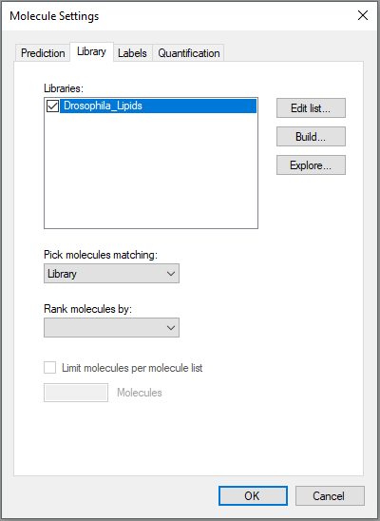

* Click the **OK** button in the **Molecule Settings** form.

To open the library explorer and view the contents of the library you just added, do the following:

* From the **View** menu, click **Spectral Libraries.**

The library explorer should now look like this:

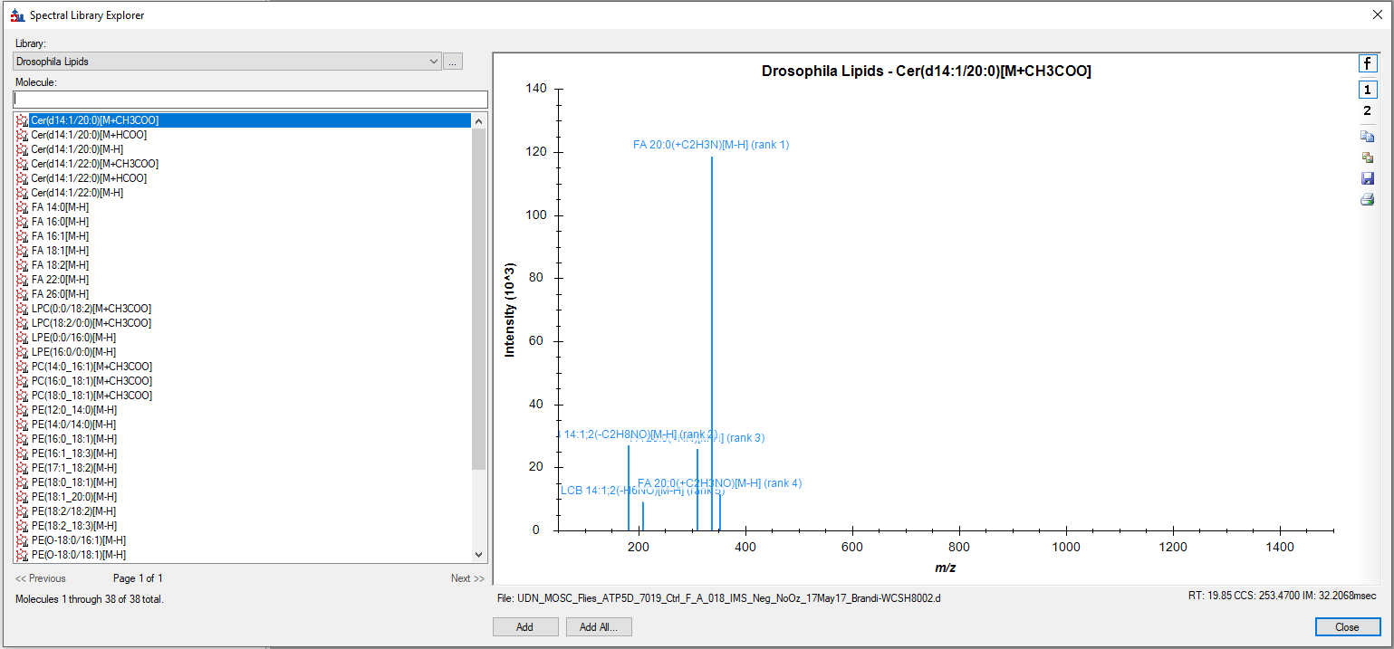

On the left side of the explorer, the **Library** list illustrates that you are currently viewing the Drosophila_Lipids library. The **Molecule** list below it shows the lipid common names and adducts which have been matched to the spectra in this library. The **<<Previous** and **Next>>** buttons are disabled for this library, because all of its spectra can be listed in a single page. At the very bottom, the library explorer reports that the page contains 1 through 38 of a total 38 molecule spectrum matches.

Hover your cursor over any molecule, and Skyline will display the name, formula, and precursor *m/z*.

To narrow the list of molecules with the molecule filter box, do the following:

* Click in the text box above the **Molecule** list.
* Enter “PG”.

The library explorer will display all phosphatidylglycerol (PG) lipids in the library. In this case, the list is reduced to four PG lipids.

Turning your attention to the right side of the library explorer, you will see a Skyline MS/MS spectrum similar to the one Skyline displays during document editing, and in fact this chart supports most of the same features. To explore a few of these features, take note of the following:

* On the right-side toolbar, the **f** and **1** buttons should be pushed to show charge 1 fragment ions. In this library, there are no charge 2 ions.
* The retention time (RT), collision cross section (CCS) and the ion mobility spectrometry (IMS) drift time value are displayed underneath each spectrum.
* Notice that the toolbar also contains buttons to **Copy**, **Save**, and **Print** the current chart, and as with most charts in Skyline, further options can be accessed through a right-click menu.

To add all the molecules in the library to your target list:

* Click the **Add All** button.
* A popup window will then notify you that you will add 34 molecules, 38 precursors, and 246 transitions to the document. Click **Add All**.
* Click **Close** on the **Spectral Library Explorer** window.

Your Skyline window should now resemble:

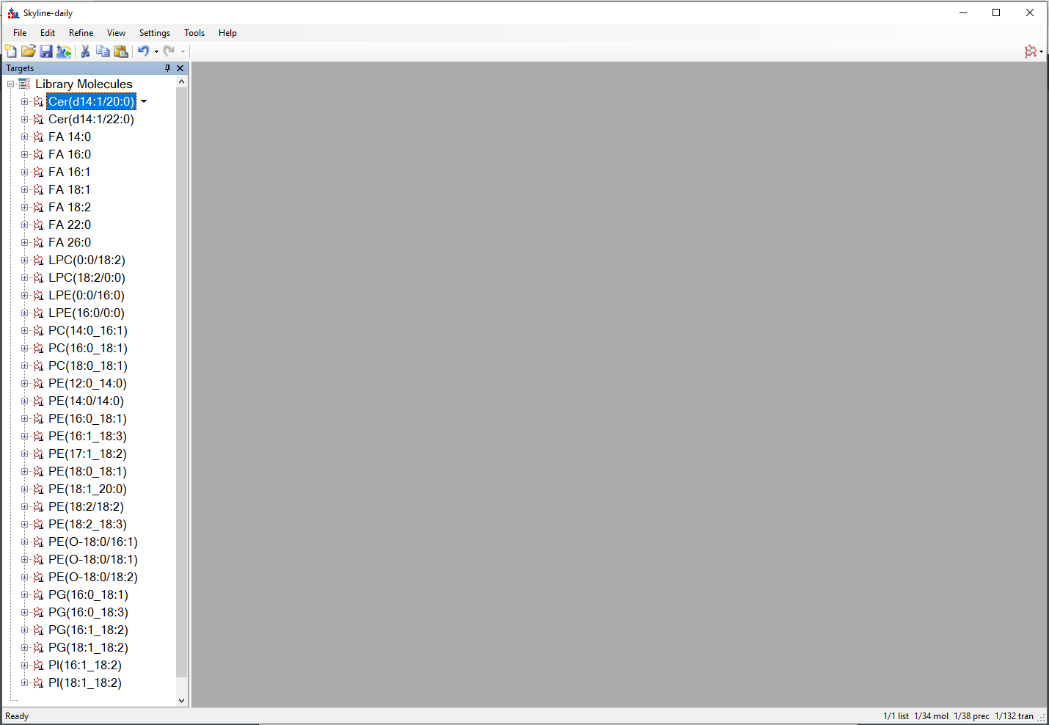

# Importing Results Data

In this section, you will import the *Drosophila* data without utilizing IMS filtering. This is an initial look at the data to see the impact of interference among lipids and their shared fragments. To import the data, perform the following steps:

* On the **File** menu, click **Save** (Ctrl+S).
* Save this document in the tutorial folder you created.
* From the **File** menu, choose **Import** and click **Results**.
* Set the **Files to import simultaneously** field to **Many**.
* Check **Show chromatograms during import**.

The **Import Results** form will appear as follows:

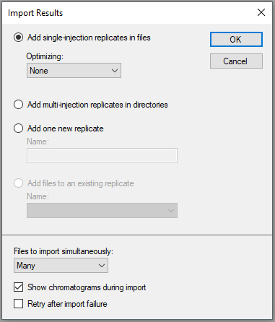

* Click the **OK** button.

The **Import Results Files** form will now show the .d files you have extracted into the tutorial folder:

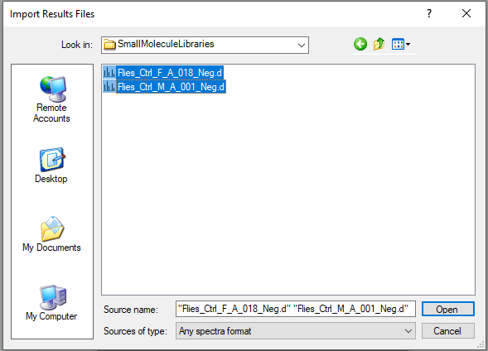

* Select both .d files.
* Click the **Open** button.
* The **Import Results** window will ask if you would like to remove the common prefix and suffix to shorten the file names used in Skyline. Click **OK** to accept the names “F_A_018” and “M_A_001”.

This should start the import and cause Skyline to show the **Importing Results** progress form:

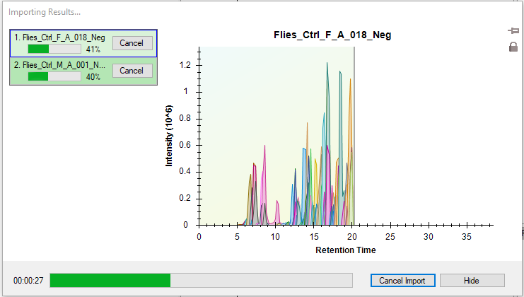

# Reviewing the Extracted Ion Chromatograms

Once the files are imported, you can examine the chromatograms to evaluate interference from peaks with retention times and *m/z* values within the tolerance of your target list.

* From the **Edit** menu, choose **Expand All** and click **Molecules** (Ctrl+D).
* From the **View** menu, choose **Arrange Graphs** and click **Tiled** (Ctrl+T).
* Right-click in a chromatogram graph and click **Synchronize Zooming** (leave if already checked).
* Right-click in a chromatogram graph and click **Legend** to hide the legend.
* Right-click in a chromatogram graph, choose **Transitions** and click **Split Graph** (leave if already checked).
* Select the molecule PC(16:0_18:1) and your spectra should appear as:

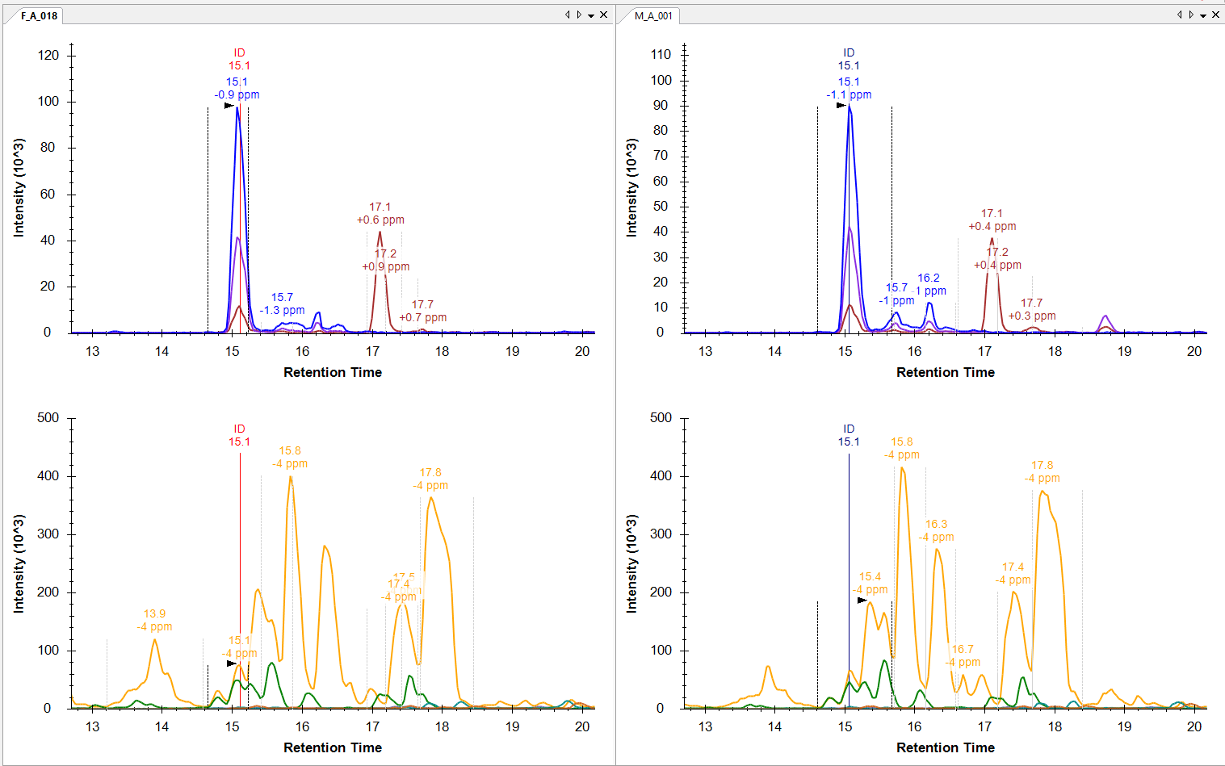

Note that while the precursor extracted ion chromatogram (XIC) is clean, the transitions for FA 16:0(+O) and FA 18:1(+O) are highly abundant across a large portion of the XIC. This is due to the nature of lipid fragmentation, as most lipids with 16:0 or 18:1 fatty acyl chains will share those same fragments. Similar results will be observed for each lipid you select, especially the other phospholipids (PC, PE, PG, PI).

Since there are only 38 precursors in this document, you may want to review all 38 to get an overall feel for how the XIC look prior to IMS filtering. Before starting this review, do the following:

* From the **View** menu, click **Library Match** (Alt+1). Alternatively, click the library match ID marker displayed on the chromatogram. This should bring up the **Library Match** view:

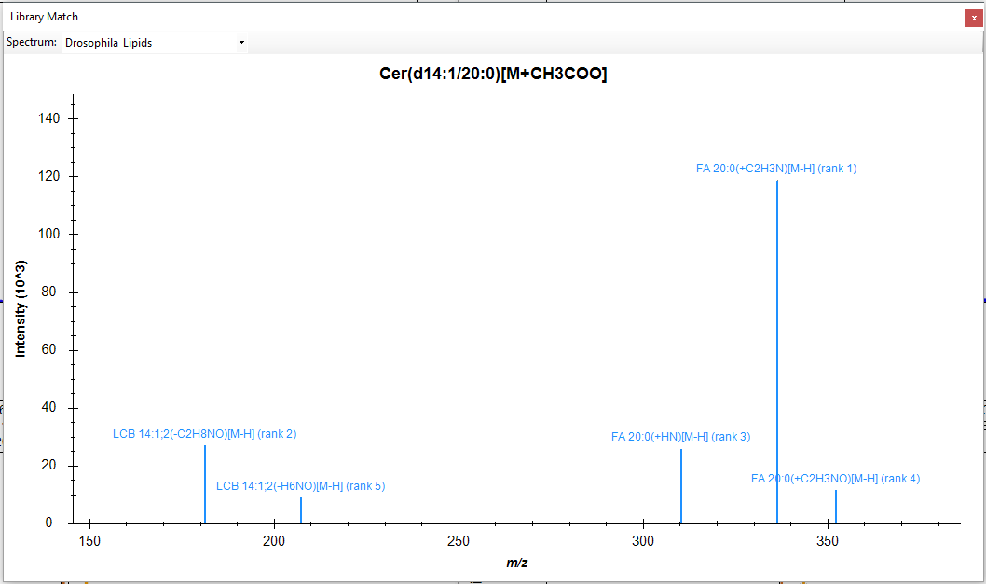

* Attach the **Library Match** view to the right edge of the Skyline window by clicking in the title bar and dragging until the mouse cursor is inside the right-side docking icon.
* On the **View** menu, choose **Retention Times** and click **Replicate Comparison** (F8).
* Attach the **Retention Times** view to the left of the **Library Match** view by clicking in the title bar and dragging until the mouse cursor is inside the left-side docking icon.
* Right-click in the **Retention Times** view and click **Legend** to hide the legend in this graph.
* From the **View** menu, choose **Peak Areas** and click **Replicate Comparison** (F7).
* Attach the **Peak Areas** view above the **Retention Times** view by clicking in the title bar and dragging until the mouse cursor is inside the up-side docking icon.
* Right-click in the **Peak Areas** view and click **Legend** to hide the legend in its graph.

You should end up with a similar layout to that below:

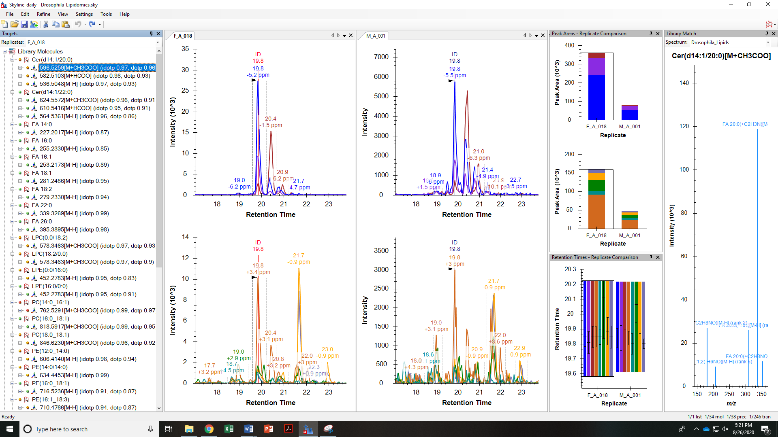

If this layout is too crowded for your display, you can close the **Library Match** view and dock the **Retention Times** and **Peak Areas** views side-by-side.

* Click on the XIC and use the mouse or touchpad to scroll (using a scroll-wheel or two-fingers respectively) to view the data more closely.

Skyline often does a good job picking peaks and most integration boundaries do not need to be edited. However, there are a few isomer pairs that require some manual peak picking.

The first two cases are the lysophospholipids (LPC and LPE), which are phospholipids with one fatty acyl chain cleaved off. These molecules chromatographically separate depending on the *sn*- position of the single fatty acyl chain. Here the library match ID retention time markers can be utilized to determine the elution order of the LPC(0:0/18:2)/LPC(18:2/0:0) and LPE(0:0/16:0)/LPE(16:0/0:0) pairs.

* Drag the integration boundaries with your mouse to integrate the correct peaks.

Note that male and female fruit flies have vastly different lysophospholipid profiles, which was also observed across almost all lysophospholipids in a larger *Drosophila* study.

The final isomer pair is near the bottom of the document. PG(16:0_18:3) and PG(16:1_18:2) have different fatty acyl compositions, but the same total number of carbons and double bonds, causing them to share the same precursor formula and *m/z* value.

* Again, use the library match ID retention time markers to determine the correct peak for each lipid.
* To integrate the correct peaks, either drag the integration boundaries with your mouse or click the retention time above the peak apex.

The product XIC may not be useful until IMS filtering is utilized.

# Understanding and Utilizing the IMS Separation

To this point, the IMS dimension in this data has been ignored. To better understand the IMS separation, you need to look at the underlying spectra from which these chromatograms were extracted by doing the following:

* On the **View** menu, choose **Auto-Zoom** and click **Best Peak** (F11).
* Select the molecule PE(16:1_18:3).
* Hover the mouse cursor over the precursor chromatogram peak apex until a blue circle appears that tracks the mouse movement, and click on it.

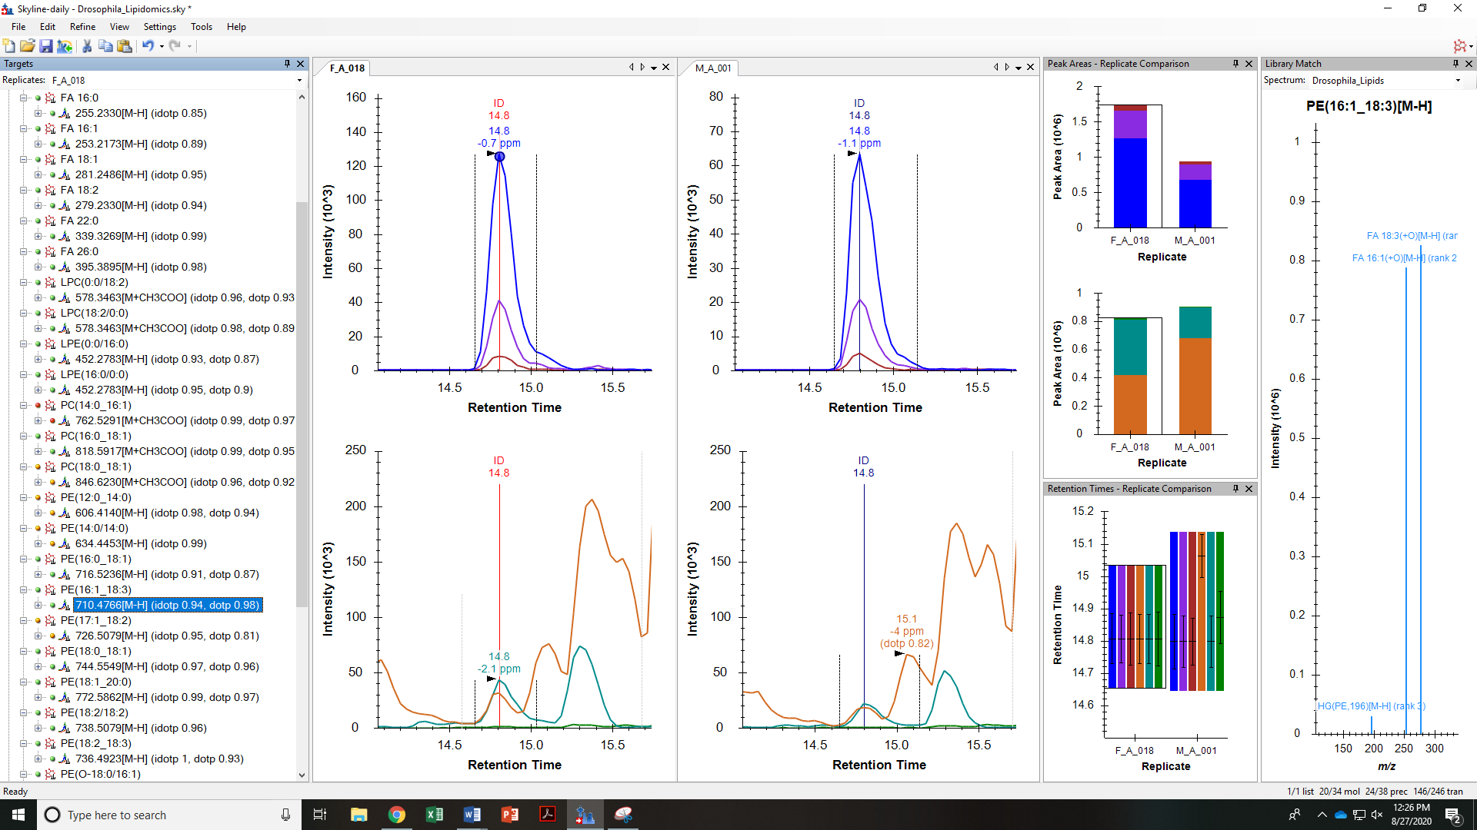

This should bring up the **Full-Scan** view showing a familiar two-dimensional spectrum in profile mode:

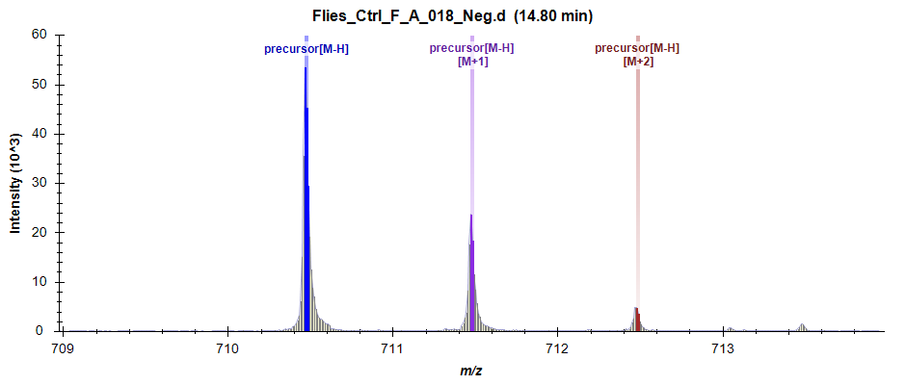

* Click the **Show 2D Spectrum** button to change the plot to a three-dimensional spectrum with drift time.

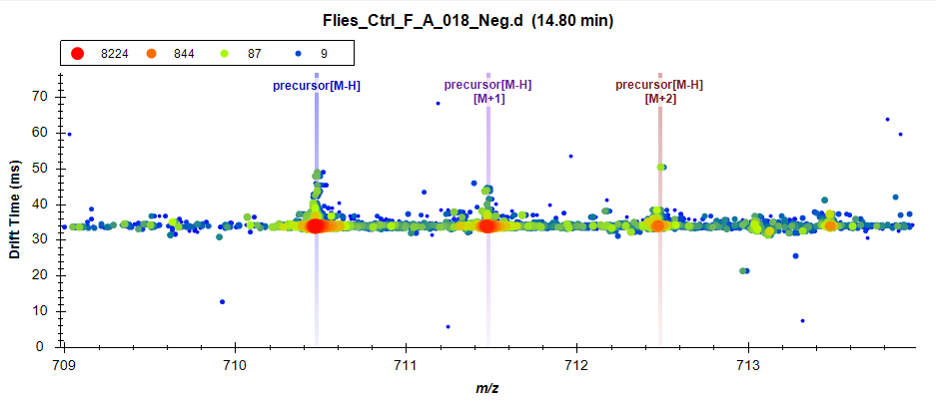

You can see that there is small interference above the most intense visible ion.

* Take a closer look by placing your cursor in the center of the plot and use the mouse-centered zooming to zoom in. You can also place your cursor to the left of the y-axis or below the x-axis to zoom one axis only.

These two ions are well-separated by IMS with the most intense ion below 34 ms and the interference above 36 ms.

* Click the **Zoom to Selection** button to see the entire 3D MS1 spectrum at the selected retention time.

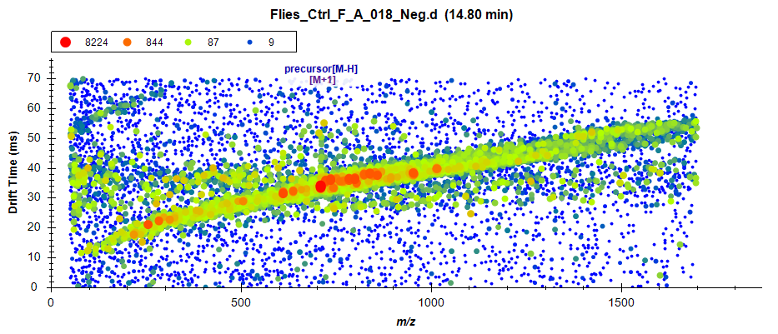

This is a fairly typical MS1 spectrum for IMS-MS lipidomics data. You can get a better sense of the data by zooming into multiple areas on this plot. You can also select other lipids and click on the blue circle at the apex of each precursor chromatogram peak to see how this plot can differ with retention time. An interesting example is PE(O-18:0/16:1), which has distinct ion distributions showing correlations between *m/z* and drift time for different lipid classes.

To inspect a relevant MS/MS spectrum:

* Re-select the molecule PE(16:1_18:3) if you navigated away from it to view other MS1 spectra.
* Click on the **Zoom to Selection** button to zoom back in.
* Hover the mouse over the FA 18:3(+O) fragment chromatogram peak apex until a teal colored circle appears that tracks the mouse movement, and click on it.

The Full-Scan graph should change to:

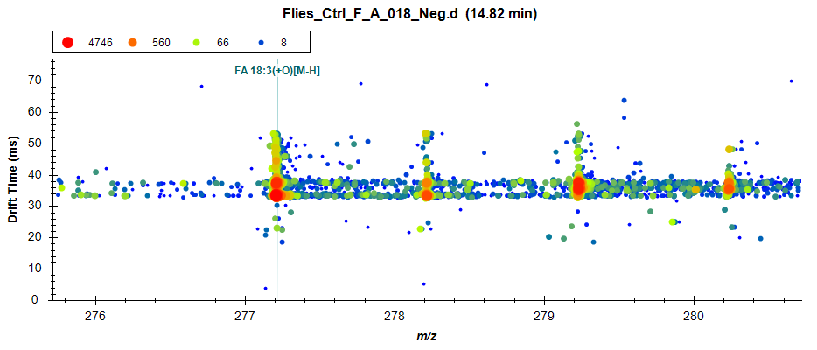

You can see that at least three visible ions are contributing to the extracted intensities at 33, 37, and 44 ms. This goes back to the nature of lipid fragmentation as previously discussed, where most lipids with an 18:3 fatty acyl chain will share this fragment. The complexity is increased for fatty acyl chains fragments with fewer double bonds, such as 18:2 at *m/z* 279, which may have multiple ions as well as isotopic overlap from the abundant 18:3 fragment at *m/z* 277 contributing to the extracted intensity. A similar observation can be made with the FA 16:1(+O) fragment.

* Click the **Zoom to Selection** button again to see the entire 3D MS/MS spectrum.

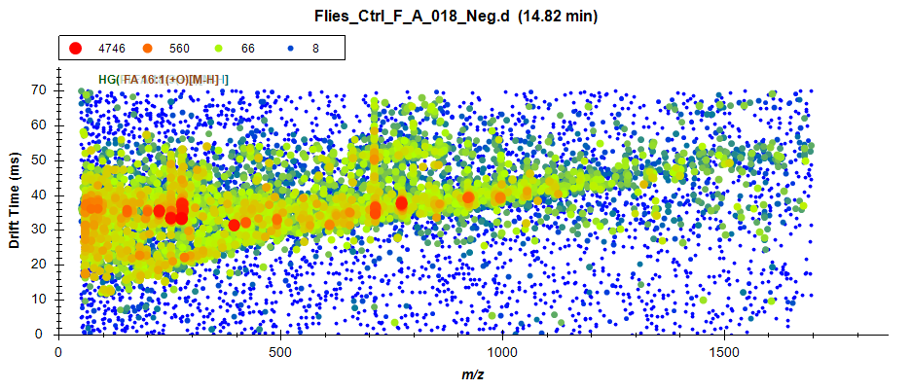

This is also a typical IMS-MS/MS spectrum, where you can imagine each horizontal stripe as a top-down view of a normal 2D spectrum. Clearly, there are many signals in this 3D space other than the one extracted at 34 ms.

# Reimporting Data with Drift Time Filtering

It should now be clear that the selectivity of chromatogram extraction in MS/MS and even MS1 can be made more selective utilizing IMS and extracting only a limited drift time range around the area of interest.

Skyline can learn and apply the IMS drift times directly from the results data, which is explained in detail in the Training a Drift Time Predictor section of the [Skyline Ion Mobility Spectrum Filtering tutorial](https://skyline.ms/_webdav/home/software/Skyline/@files/tutorials/IMSFiltering-3_7.pdf). In this tutorial, however, you may recall that the spectral library contains collision cross section (CCS) values for each molecule, which can now be use to extract only limited drift time ranges for additional identification confidence and selectivity.

Prior to changing the settings and reimporting the data, you may want to save the current Skyline document and create a second file in order to compare the data before and after IMS filtering. To do so:

* On the **File** menu, click **Save As..**.
* Save the file with a different name than your original Skyline document, such as “Drosophila_Lipids_Neg_IMS_Filtered”, in the tutorial folder you created.

The data files have been Single Field Calibrated using vendor software, meaning Skyline can easily convert between drift time and CCS. CCS values are normalized and reproducible, allowing the use of previously determined CCS (from databases and standards) to filter the data. To utilize the IMS information stored in the library, the following steps are performed:

* From the **Settings** menu, click **Transition Settings**.
* Click the **Ion Mobility** tab.
* Check **Use spectral library ion mobility values when present**.
* Set the **Window Type** field to **Resolving power**.
* In the **Resolving power** field, enter “50”.

The **Transition Settings** should now look like:

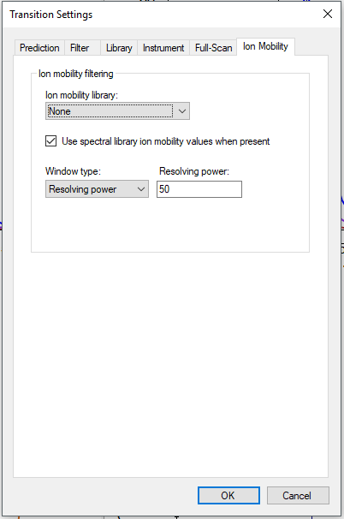

* Click the **OK** button.

The results must now be reimported with the newly applied IMS settings.

* From the **Edit** menu, click **Manage Results**.
* Make sure that F_A_018 is highlighted.
* Click the **Re-import** button. “*” Should appear to the left of F_A_018.
* Select M_A_001 in the **Manage Results** view.
* Click the **Re-import** button. “*” Should appear to the left of M_A_001.
* Click the **OK** button.

This should start the re-import and cause Skyline to show the **Importing Results** progress form.

* Click any other lipid in the Target list and re-select PE(16:1_18:3) to update the chromatograms.

To explore the filtered data, perform the following:

* Click on the apex of the blue precursor chromatogram to show the Full-Scan graph.
* Click the **Zoom to Selection** button.

The **Full-Scan** graph should now look something like this:

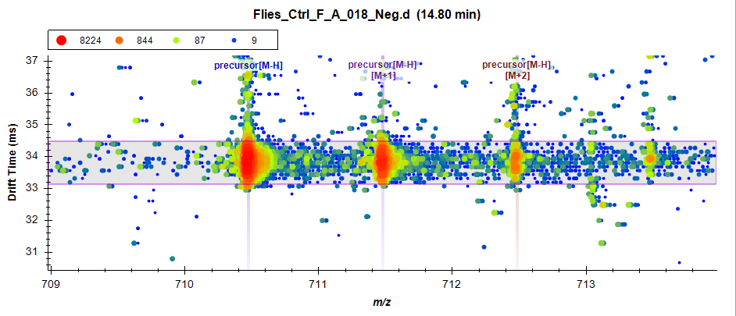

The horizontal violet range showing the filter imposed by the CCS (261 Å2) is now visible and stored in the spectral library. The signal outside of this drift time range is also now ignored by Skyline. Therefore, the interference at 36 ms has been removed. To view the filtered MS/MS data:

* Click on the apex of the teal and orange fragment chromatogram.

You may notice that the fragment ions have a slightly lower drift times than the precursor. This occurs because the voltage applied in the collision cell causes the smaller fragment ions to have a higher velocity and arrive at the detector slightly faster than the larger precursor ions. This is accounted for by adding high energy drift time offset values to the spectral library.

Select other targets to compare the current XICs to those observed prior to drift time filtering. To further investigate the filtering of interferences, click on the apex of the precursor and fragment peaks.

Note that if you were interested in lipids that are not present in the current spectral library, you can add to it manually or using LipidCreator. To access the LipidCreator plugin, do the following:

* From the **Tools** menu, click **Tool Store**.
* Select **LipidCreator**.
* Click the **Install** button.

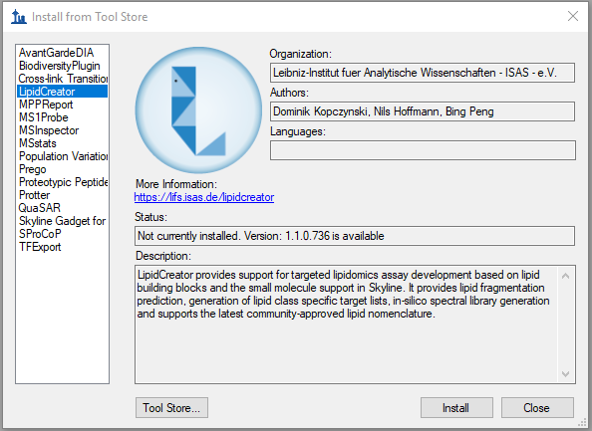

A progress form should appear as LipidCreator is downloading. When it finishes, LipidCreator can be accessed directly from the **Tools** menu.

The following steps can be taken to easily export an updated spectral library:

* From the **File** menu, choose **Export** and click **Spectral Library**.
* Enter a file name and click **Save**.

# Conclusion

In this tutorial, you have learned how to work with small molecule spectral libraries and IMS data in Skyline. You now understand the settings required for chromatogram extraction from this data. You can import, export, and inspect the contents of any small molecule spectral library. You have learned to interpret the alternating MS1 and MS/MS three-dimensional spectra produced by an IMS enabled mass spectrometer for complex lipidomics datasets. You can now use CCS values for drift time filtering to enhance the selectivity of chromatograms extracted by Skyline. Having completed this tutorial, you should be ready to take full advantage of multidimensional spectral libraries to improve your analysis of small molecules.